

|  |
| --- |
| **Microcontroller-Driven Indoor Hydroponic Fodder System** |

Product-based project (IoT or Wireless Sensor Networking or Networking)

**MAIN SUPERVISORMISS**

**MS. NADUNI JAYATHILAKE**

**A.K.RANAWEERA -ITBNM-2110-0046**

**Problem Definition**

Fodder production is an important aspect of agriculture . Most urban sites face issues like limited space, poor or unsuitable soil, and the amount of time taken up by traditional gardening in raising one's own fresh produce. Manual approaches to watering and nutrient delivery are extremely labor-intensive and susceptible to human error, often overusing resources. In addition, small- and medium-scale farmers form the backbone of agricultural economies, too often lacking cost-effective solutions that effectively optimize their fodder production processes. though they may require constant human intervention and expertise. A dire need exists for user-friendly automated hydroponics that can also be controlled and monitored using a mobile application for even novice growers. The purpose of this project is to develop

The app-remote smart automated hydroponic system will be very helpful in monitoring these key parameters for ideal plant growth, such as nutrient levels, temperature, power, and lighting. In turn, this will offer users a very easy and effective procedure in the management of indoor gardens, contributing to urban farming that is more sustainable and accessible. Also It also automatically manages the processes of water and nutrient delivery,. This innovation cuts dependence on external factors, reduces resource use, and offers an affordable, scalable solution to small-scale farmers seeking to enhance productivity and sustainability in fodder production.

**Key Features**

1. Automated Water and Nutrient Delivery:

* Sensors detect the nutrient levels, automatically delivering the required amount of water.

1. Automation Process:

* If it detects darkness, automatically turn on the light. Also changing environment conditions suitable for plants via changing hot and cold.

1. Real-Time Monitoring:

* IoT-enabled sensors provide real-time updates on environmental conditions, which include temperature, humidity, and light intensity.

1. Energy-Efficient Operations:

* Integrate with solar panels to make the system power itself sustainably.

1. Cost-Effective:

* Uses readily available components, making it affordable for small- and medium-scale farmers.

1. Data Logging and Visualization**:**

* Logs sensor data for analysis and displays real-time updates on an LCD screen or cloud platform

**Hardware Components**

* **Arduino board** –( Acts as the central microcontroller to receive inputs from sensors, process data, and control outputs like displays, pumps, or LEDs.)
* **moisture sensor** –( Measures the moisture level in the soil. Commonly used in gardening or agriculture to monitor soil hydration.)
* **DHT 11 sensor** –( Measures temperature and humidity. Useful for environmental monitoring or controlling climate in a controlled space like a greenhouse.)
* **LCD Display** - (Shows information such as sensor readings, status messages, or alerts to the user in a readable format.)
* **Water level sensor** –( A water level sensor is a device used to detect and measure the level of water or other liquids within a container, tank, or system. It plays a critical role in monitoring and controlling water levels, particularly in automated systems.)
* **TDS sensor** –( Measures the Total Dissolved Solids (TDS) in water, indicating its purity or contamination level.) S
* **LDR sensor** –( Measures light intensity. Can be used for light level detection or to control lighting based on ambient light conditions.)
* **ESP8266** –( A Wi-Fi module that enables your project to connect to a wireless network for internet access or remote control.)
* **Turbidity sensor** –( Measures the cloudiness or haziness of a liquid. Often used to assess water quality.)
* **Water pump** – (Used to move or circulate water, often for irrigation or hydroponic systems.)
* **Exhaust Fan** –( Provides ventilation to remove heat or fumes, improving air quality in an enclosed space.)
* **LED** –( Light Emitting Diode, used for visual indicators or status lights.)
* **Battery Pack** –( Provides power to the entire system when not connected to an external power source.)
* **Breadboard and Connecting Wires** –( Used for prototyping and connecting electronic

components without soldering.)

**Software Components**

* Arduino IDE
* Web site Development (React )
* Cloud Service (firebase)

**block diagram**

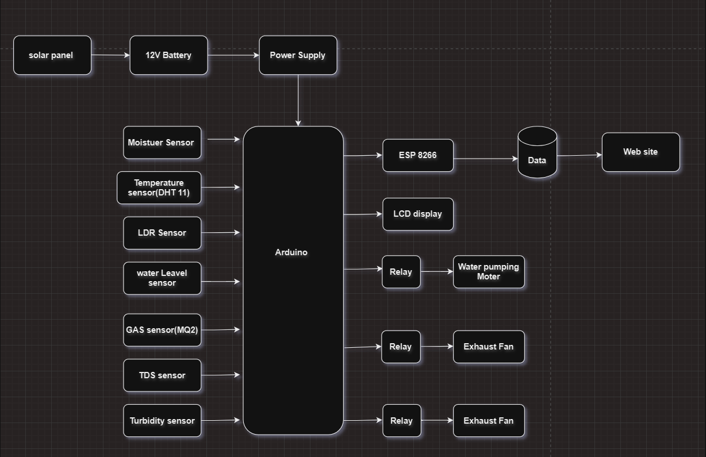

**circuit diagram**

